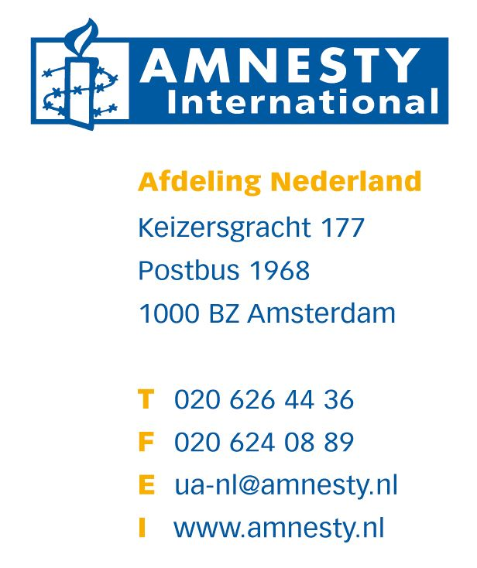

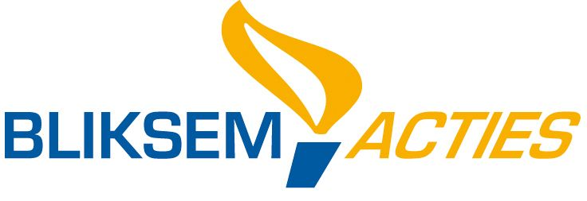
Amnesty International streeft naar een wereld waarin iedereen alle rechten geniet die zijn vast gelegd in de Universele Verklaring van de Rechten van de Mens en andere internationale mensenrechtendocumenten. Amnesty doet onderzoek en voert actie gericht op het tegengaan en stoppen van ernstige schendingen van al deze rechten.
AI Index: | AMR 37/011/2010
Datum: | 29 juli 2010
UA nr: | 166/10
Land: | HONDURAS

HONDURAN LAWYER AT RISK

The car of a Honduran human rights lawyer has been broken into, her papers searched and a laptop computer stolen. Amnesty International believes that she has been targeted because of her human rights work, and she may be in danger.

On 21 July, Kenia Oliva Cardona, a lawyer with the Honduran human rights organization Committee of Relatives of the Disappeared in Honduras (Comité de Familiares de Detenidos Desaparecidos en Honduras, COFADEH) found that her car had been broken into, documents inside the car searched through and some taken, and a laptop computer stolen from the car boot. Kenia Oliva had left her car parked around 100 metres from the offices of the Public Prosecutor’s Office in the capital, Tegucigalpa, while she spent two hours inside the building, reviewing the progress of a number of cases of human rights abuses which had been filed by COFADEH. Many of the cases where COFADEH has filed official complaints allege state security forces' involvement in the human rights abuses.

On examining her car, Kenia Oliva discovered that a window had been broken so that the car could be opened from the inside, and that all of the compartments inside the car had been searched and the car boot opened. Documents related to a course in human rights law which Kenia Oliva is studying for had been taken, while valuable items such as the car radio had been left behind. The laptop computer stolen from the car boot contained confidential information related to COFADEH's work.

In November 2009, the Inter-American Commission on Human Rights (IACHR) called on the Honduran authorities to protect Kenia Oliva, along with another 16 members of COFADEH and their immediate families. This order has not been effectively implemented, leaving Kenia Oliva and the other 16 COFADEH members at risk.

ACHTERGRONDINFORMATIE

COFADEH is one of Honduras’s main human rights organizations, and has been at the forefront of efforts to document and report human rights violations both in the context of the 28 June 2009 coup d’état which deposed President José Manuel Zelaya, and during the administration of President Porfirio Lobo, who took office on 27 January 2010 following elections in November 2009.

Many of the cases investigated by COFADEH allege the involvement of state security forces in human rights abuses.

COFADEH has also been active in the legal defence of activists from the Resistance movement (a broad-based opposition alliance of individuals and organizations which emerged in response to the 28 June 2009 coup) who were charged with public order and political offences following demonstrations against the coup d’état in 2009.

In April 2010, two police officers and two soldiers were found guilty of the killing of an unarmed civilian in 2007. The case was one on which Kenia Oliva had been working, providing legal support to the victim’s relatives.

On 30 September 2009, Kenia Oliva defended 49 campesinos (peasants and rural workers) who had occupied the offices of the National Agrarian Institute (INA) following the 28 June 2009 coup d’état in order to protest at the coup and to protect the land claims titles held in the INA which they feared could be destroyed. When she left the police station where the hearing had been held, Kenia Oliva found that the left-side wheel bolts at the front of her car had been loosened. Her car had been parked in front of the police station. Amnesty International has also campaigned for Rosa Vargas, an opposition activist, whose car was interfered with in a similar way in December 2009
(see http://www.amnesty.org/en/library/info/AMR37/006/2010/en).

On 22 September 2009, around 15 police officers fired tear gas canisters into the confined space of the COFADEH offices, where scores of pro-Zelaya protesters had taken refuge. Around 100 people, including children, were inside the office at the time. The demonstrators had taken refuge in the offices of the human rights organization to avoid further abuses by the police and military forces and to document abuses which they had suffered during a demonstration.

AANBEVOLEN ACTIE:

stuur een brief gebaseerd op onderstaande schrijfaanwijzingen

* calling for an independent, thorough and impartial investigation into the theft of the documents and laptop computer from Kenia Oliva’s car on 21 July, with the results made public and those responsible brought to justice;
* urging that the authorities take immediate steps to fully comply with IACHR order to provide appropriate protection to Kenia Oliva and the other 16 COFADEH staff and their immediate families in line with the IACHR request of 17 November 2009;
* reminding the authorities that human rights defenders have a right to carry out their activities without any unfair restrictions or fear of reprisals, as set out in the UN Declaration on Human Rights Defenders.

STUUR UW BRIEVEN NAAR:

President
Sr. Porfirio Lobo Sosa
Presidente de la República
Casa Presidencial
Boulevard Juan Pablo Segundo
Palacio José Cecilio del Valle
Tegucigalpa
HONDURAs
Fax: + 504 239 3298
Aanhef: Dear President

Attorney General
Sr. Luis Alberto Rubí
Fiscal General de la República
Lomas del Guijarro
Avenida República Dominicana
Edificio Lomas Plaza II
Tegucigalpa
HONDURAS
Fax: + 504 221 5667
Aanhef: Dear Attorney General

STUUR KOPIEËN NAAR:

NGO:
Comité de Familiares de Detenidos Desaparecidos en Honduras (COFADEH)
Barrio La Plazuela, Avenida Cervantes, Casa No. 1301
Apartado Postal 1243
Tegucigalpa
HONDURAS
Fax:+ 504 220 5280 (say "tono de fax por favor")

De diplomatieke vertegenwoordiger van Honduras in Nederland:
Ambassade van Honduras
Burgemeester Patijnlaan 1932
2585 CB Den Haag
Fax: 070 3649134
E-mail: eholan@honduras.demon.nl

Zend de brieven graag zo snel mogelijk. Als u brieven wilt versturen ná 9 september 2010 neemt u dan contact op met het landelijk secretariaat van Amnesty International.

